

Semester 2, 2019/20

Revision Assignment

Section 3

Prepared by :

|  |  |
| --- | --- |
| NAME | MOHAMED MOUBARAK MOHAMED MISBAHOU MKOUBOI |
| MATRIC NO | 1820705 |

Question 1: Watermelon

public static void main(String arg[]) {

Scanner reader = new Scanner(System.***in***);

// exo1 : watermelon

System.***out***.println("Enter a number: ");

int num = reader.nextInt();

if (num >= 2 && num%2 == 0) {

System.***out***.println("YES");}

else {

System.***out***.println("NO");

}

Output:

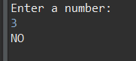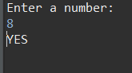

Question 2: Even digits

System.***out***.println("Enter two numbers: ");

int count = 0;

int m = reader.nextInt();

int n = reader.nextInt();

for (int i = m ; i < n ; i++) {

if (i % 2 == 0) {

count ++;

}

}

System.***out***.println("Even numbers are: " + count);

Output:

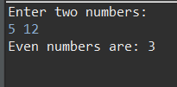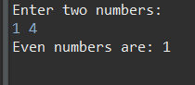

Question 3: Sum digits

int sum = 0;

System.out.println("Enter a number: ");

int num = reader.nextInt();

while (num != 0) {

sum += num %10;

num /= 10;

}

System.out.println("The sum of the number is: " + sum);

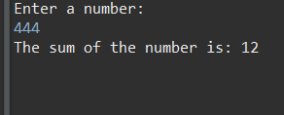Output:

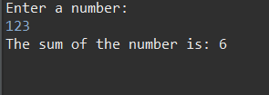

Question 4: Count max digit:

int max = 0;

int count = 0;

System.out.println("Enter a number: ");

for(int i=0 ; i<6 ; i++) {

int n = reader.nextInt();

if (n > max) {

max = n;

count = 1;

}

else if (n == max) {

count ++;

}

}

System.out.println( max + ", " + count );

Output:

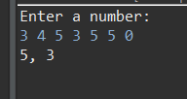

Question 5: Powers:

System.***out***.println("Enter two numbers: ");

int n = reader.nextInt();

int m = reader.nextInt();

int total = 1;

while(m != 0) {

total *= n;

m --;

}

System.***out***.println("The result is: " + total);

Output:

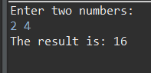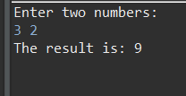

Question 6: Palindrome:

System.***out***.println("Enter a number: ");

int n = reader.nextInt();

int result = 0;

int temp = n;

while (n != 0) {

result *= 10;

result += n % 10;

n /= 10;

}

if (result == temp)

System.***out***.println(temp + " is a palindrome.");

else

System.***out***.println(temp + " is not a palindrome.");

Output:

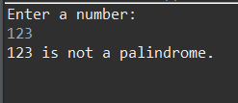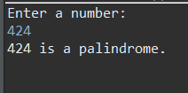

Question 7: Winners:

System.***out***.println("Enter the number of players and the score: ");

int n = reader.nextInt();

int k = reader.nextInt();

int[] player = new int[n];

for (int i = 0; i < n; i++) {

player[i] = reader.nextInt();

}

int counter = 0;

for (int i = 0; i < n; i++) {

if (player[i] >= player[k-1] && player[i] > 0)

counter++;

}

System.***out***.println("The number of players qualifying is: " + counter);

Output:

